TITLE

“ElectViz Election Data Visualization
on for Media”


Presented by:
K.Srilakshmi Sowjanya

Index:

Abstract 3-4
Problem Statement & solution 4-7
Introduction 7-9
Data Flow Diagrams 10-13
Technology Used 14
Modules with Explanation 14-19
Future Enhancement 20
Advantages and Disadvantages 21-23
Conclusion, Learning 23-24
Screenshots 25-26

Abstract:

ElectViz is an innovative Power BI-based platform designed to assist media organizations in delivering real-time, interactive, and insightful election coverage. By integrating official data from multiple constituencies and polling booths, the system provides a comprehensive view of electoral outcomes across regions. Using Power BI’s ETL (Extract, Transform, Load) capabilities, ElectViz cleanses, structures, and transforms raw election data into formats suitable for visualization, ensuring accuracy and consistency even with large, diverse datasets.
The platform presents data through dynamic dashboards, charts, and graphs, enabling media professionals to explore trends, voter behaviour, and real-time results with ease. Users can filter and drill down data by constituency, polling booth, party, or candidate, allowing for detailed analysis and timely reporting. ElectViz supports a variety of visualization formats, including bar charts, line graphs, heat maps, and geographical maps, making complex election data accessible and comprehensible.
One of the key strengths of ElectViz is its ability to deliver real-time insights, supporting live monitoring of vote counts, seat projections, and voter turnout. This functionality empowers journalists, analysts, and editors to provide accurate and timely updates, enhancing both the transparency and credibility of election coverage. Additionally, ElectViz facilitates public engagement by presenting election data in visually appealing, interactive formats that allow audiences to understand results intuitively.
In summary, ElectViz transforms raw electoral data into an effective storytelling and analytical tool, combining precision, interactivity, and visual clarity. It improves the way media organizations interpret, report, and communicate election outcomes, making election coverage faster, clearer, and more engaging for both professionals and the public.

Problem Statement:
Elections generate vast amounts of data from multiple constituencies, polling booths, and phases of voting. Media organizations are tasked with analyzing, interpreting, and reporting this data accurately and in real-time to inform the public. However, the current methods of election reporting often face several challenges:
- Data Overload: Raw election data from numerous sources is extensive and unstructured, making it difficult to process manually. Journalists and analysts struggle to extract meaningful insights quickly.
- Delayed Reporting: Traditional methods of data compilation and reporting are time-consuming, leading to delays in delivering accurate election results to the public.
- Lack of Interactivity: Most existing reporting systems present static tables and text-based results, limiting the ability of media professionals and audiences to explore data dynamically.
- Inconsistencies and Errors: Aggregating data from multiple sources increases the risk of inconsistencies, inaccuracies, and misinterpretation, which can undermine public trust in election reporting.
- Limited Public Engagement: Complex data is often not presented in an easily understandable or visually appealing manner, reducing audience engagement and comprehension.
During elections, media houses often face the challenge of:
*Handling large, complex datasets
*Delivering results in real-time
*Generating engaging and easy-to-understand visualizations
*Traditional reporting methods (Excel sheets, static tables) are slow, error-prone, and not interactive. ElectViz solves these issues by leveraging Power BI dashboards for dynamic election visualization.
Solution:
To address the challenges in accurate, timely, and interactive election reporting, ElectViz provides a comprehensive solution using Power BI’s advanced data visualization and analytics capabilities. The platform is designed specifically for media organizations to transform complex electoral data into actionable insights, enabling real-time analysis and reporting.
Key Features of the Solution:
- Data Integration: ElectViz integrates official election data from multiple sources, including constituencies, polling booths, and election commissions. It consolidates raw data into a structured format, ensuring accuracy and reliability.
- ETL Processing: Using Power BI’s Extract, Transform, Load (ETL) capabilities, the platform cleanses, validates, and transforms data into a ready-to-use format. This process reduces errors, standardizes datasets, and allows efficient handling of large and diverse data sources.
- Interactive Dashboards and Visualizations: The solution presents data through dynamic dashboards, charts, and graphs, enabling media professionals to explore trends, voter behaviour, and election results intuitively. Users can filter and drill down by constituency, party, candidate, or polling booth for detailed analysis.
- Real-Time Updates: ElectViz supports live data monitoring, allowing journalists and analysts to track vote counts, voter turnout, and seat projections in real-time. This ensures that media organizations can provide timely and accurate reporting during elections.
- Enhanced Public Engagement: The platform provides visually appealing and interactive visualizations, making complex election data understandable to the general public. This promotes transparency, builds trust, and increases audience engagement.
- Custom Reports and Alerts: Users can generate customized reports and visual summaries tailored to their editorial needs. Alerts and notifications can be configured for significant updates, enabling swift dissemination of critical election information.

Benefits of ElectViz:
- Simplifies complex electoral data into clear visual insights.
- Enhances speed and efficiency in data interpretation and reporting.
- Supports accurate, reliable, and transparent election coverage.
- Encourages interactive exploration and public engagement.
- Reduces manual effort in aggregating and analyzing large datasets.
Introduction:
Elections are a cornerstone of democracy, reflecting the will of the people and shaping the future of nations. In modern elections, vast amounts of data are generated across multiple constituencies, polling booths, and phases of voting. This data includes voter turnout, vote counts for candidates, party-wise results, and constituency-level statistics. For media organizations, effectively managing and interpreting this data is critical for delivering timely, accurate, and insightful election coverage. However, the sheer volume, diversity, and complexity of election data present significant challenges. Traditional reporting methods, often based on static tables and text summaries, are insufficient for providing real-time insights or interactive analysis.
The challenges faced by media organizations in election reporting include data overload, delays in reporting, inconsistencies, and limited public engagement. Aggregating data from multiple polling booths or constituencies manually is time-consuming and prone to errors. Furthermore, static reports limit the ability of journalists and analysts to explore trends or drill down into specific segments of the data. The general public, on the other hand, may find raw numerical data difficult to interpret, reducing transparency and engagement. These challenges highlight the need for an innovative, automated, and visually intuitive solution capable of handling large datasets efficiently while providing meaningful insights in real-time.
ElectViz is designed to address these challenges by leveraging Power BI’s advanced data visualization and analytics capabilities. The platform consolidates election data from multiple sources, including official election commissions and polling booths, and transforms it using Power BI’s ETL (Extract, Transform, Load) functionality. This ensures that raw data is cleansed, standardized, and ready for analysis, reducing the risk of errors and inconsistencies. By presenting data through interactive dashboards, charts, graphs, and maps, ElectViz allows media professionals to monitor real-time election results, analyze trends, and communicate findings effectively.
A key strength of ElectViz is its ability to provide dynamic, interactive visualizations. Users can filter results by constituency, candidate, party, or polling station, and drill down to obtain granular insights. Different types of visualizations, such as bar charts, line graphs, heat maps, and geographical maps, enable quick understanding of complex election patterns. Real-time updates allow media organizations to provide instantaneous reporting, enhancing both credibility and transparency. Moreover, the visually appealing and interactive design of ElectViz facilitates public engagement, helping citizens understand election results intuitively and encouraging informed discussions.
In addition to supporting internal analysis, ElectViz serves as a public-facing tool, enabling audiences to explore election data interactively. This enhances transparency and accountability in reporting, as users can verify results and observe trends themselves. The solution also reduces manual effort in aggregating and analyzing large datasets, freeing journalists and analysts to focus on interpretation and storytelling.
In essence, ElectViz bridges the gap between complex electoral data and actionable insights, transforming raw numbers into meaningful visual stories. By combining real-time data integration, interactive visualizations, and intuitive dashboards, the platform empowers media organizations to deliver accurate, transparent, and engaging election coverage. This not only improves workflow efficiency but also strengthens public trust in the democratic process.
With the increasing importance of data-driven journalism, ElectViz represents a critical step forward in modern election reporting. By making data accessible, interactive, and understandable, it enhances the ability of media organizations to inform the public, foster engagement, and uphold the principles of transparency and accountability in elections.
ElectViz uses Power BI to transform raw election datasets into media-ready visualizations. By connecting directly to polling APIs, CSV files, or Excel sheets, Power BI processes the data and enables media teams to:
*Track constituency-wise results in real-time
*Generate party-wise vote distribution and seat trends
*Compare current results with historical data
*Publish interactive dashboards for websites and TV graphics.
Data Flow Diagrams (DFDs):
Data Flow Diagram 1:

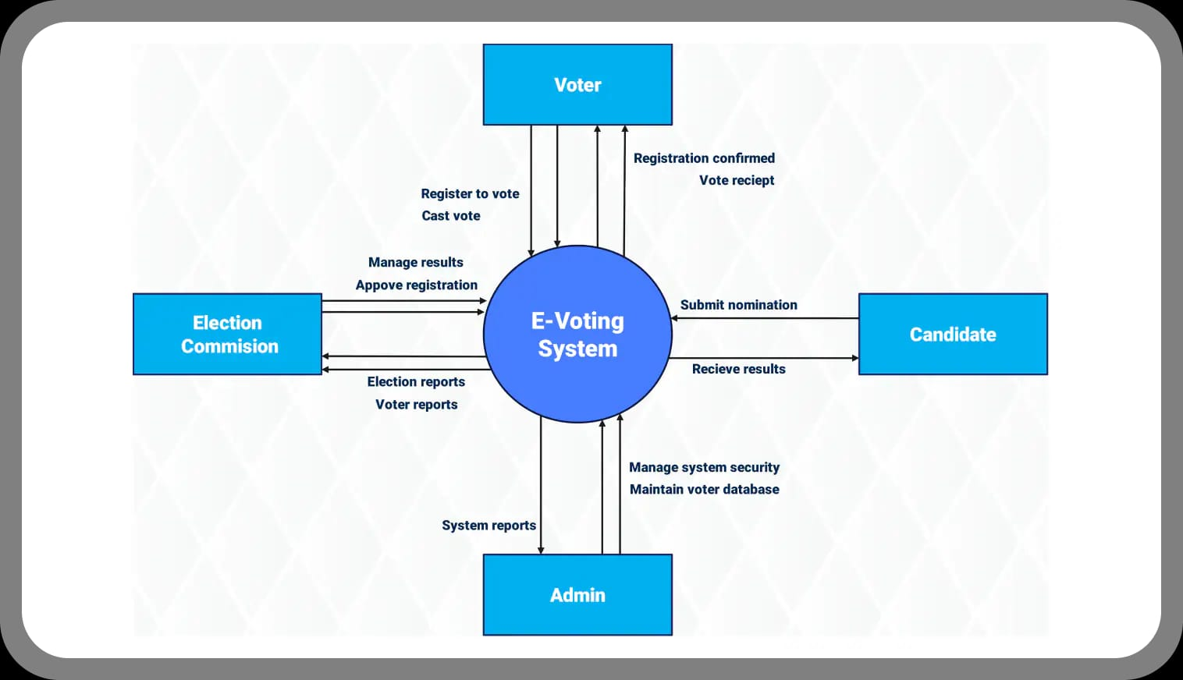

Data Flow Diagram 2:
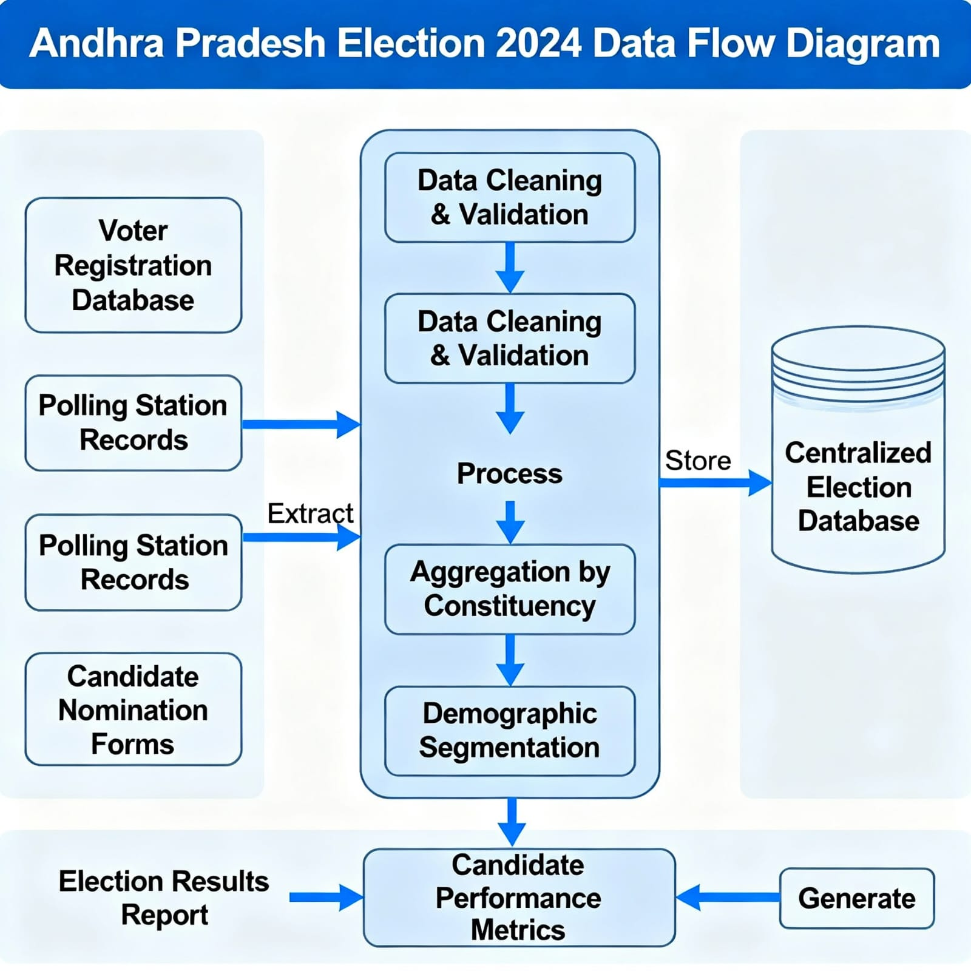

Data Flow Diagram 3:

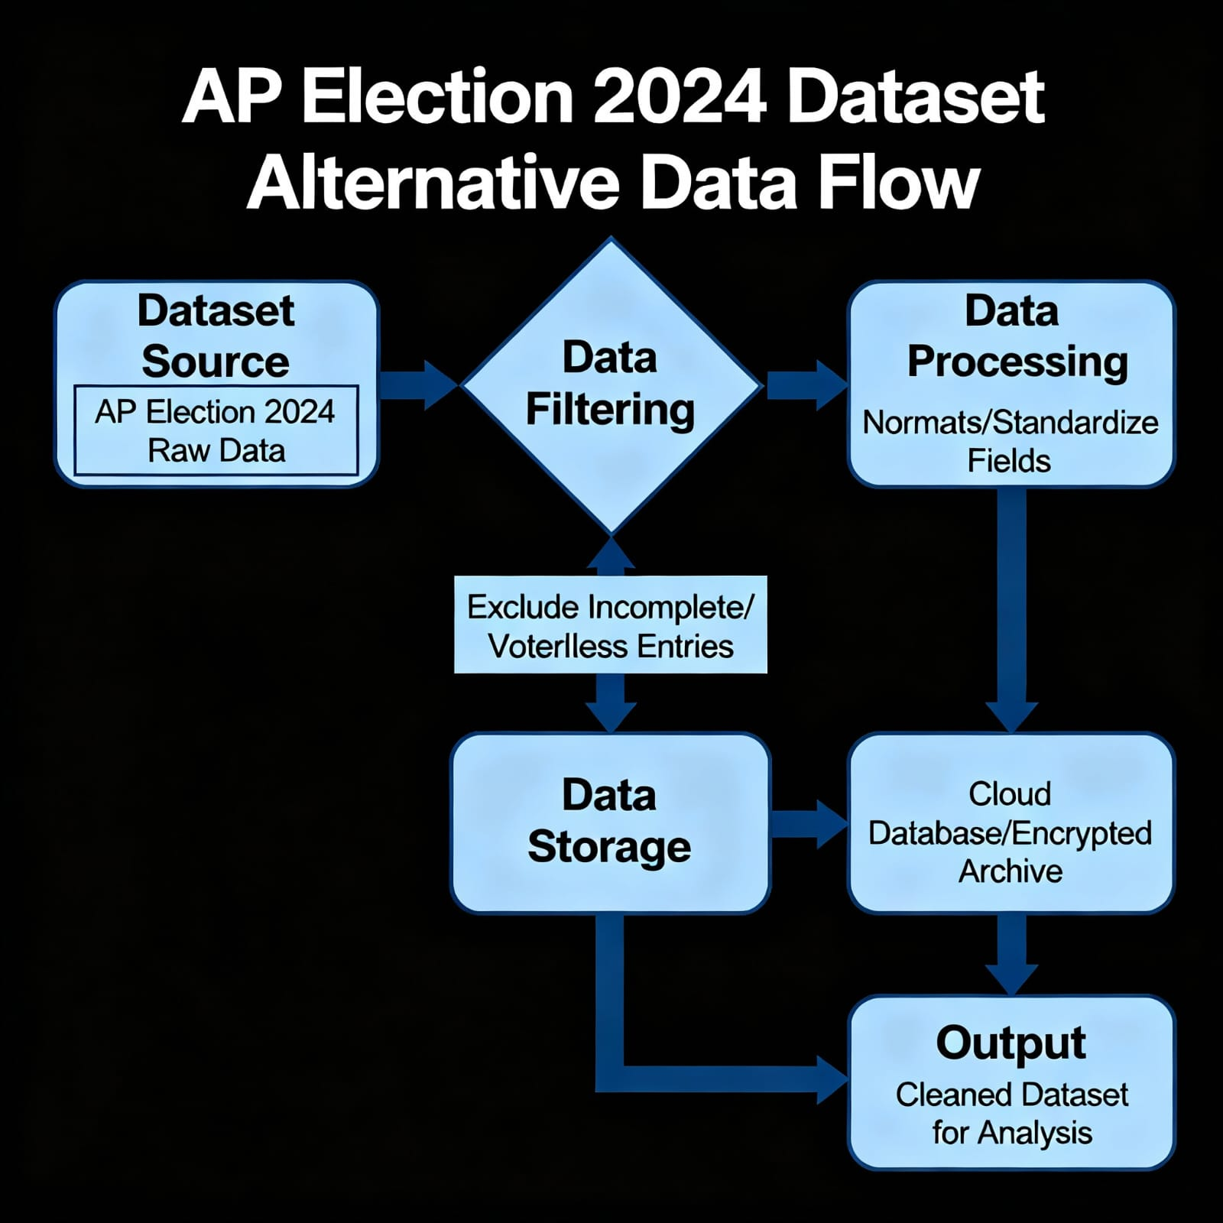

Data Flow diagram 4:
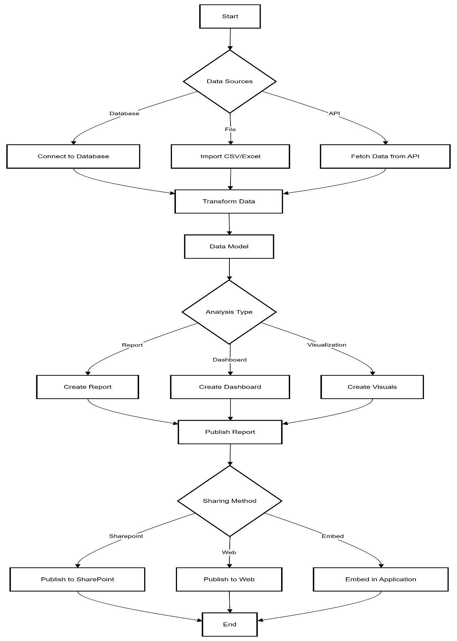

Technology Used:
*Tool: Microsoft Power BI Desktop / Power BI Service
*Database: Excel, CSV, SQL Server, or API connection
*Visualization Components: Bar charts, Pie charts, Donut charts, Maps, KPI visuals
*Power BI Features: Data modelling, DAX formulas, Relationships, Filters, Slicers
*Deployment: Power BI Service for live dashboards and cloud publishing.
Modules of ElectViz:
The ElectViz system is organized into several functional modules, each responsible for a specific aspect of data processing, visualization, and reporting. These modules work together to ensure the seamless flow of election data—from collection to real-time visualization and analysis. The modular design improves scalability, maintainability, and performance while enabling easy customization based on different media requirements.
1. Data Collection and Integration Module
This module is responsible for acquiring and aggregating raw election data from multiple sources such as official election commission databases, polling booth reports, and constituency-level data repositories. It ensures the integration of data in various formats like CSV, Excel, and JSON.
Key Functions:
- Collects constituency-wise and booth-wise election data from verified sources.
- Merges datasets from different regions into a single repository.
- Validates data accuracy and removes duplicates.
- Supports both manual uploads and automated data import using Power BI connectors.
Outcome:
Ensures the availability of clean, consistent, and up-to-date data for further processing and visualization.
2. Data Transformation (ETL) Module
Once the data is collected, it must be cleaned, standardized, and transformed to ensure uniformity across multiple data sources. This module utilizes Power BI’s ETL (Extract, Transform, Load) capabilities to automate the process.
Key Functions:
- Extracts data from integrated sources.
- Cleans and formats inconsistent entries (e.g., missing values, wrong codes, or duplicates).
- Transforms data into a unified structure suitable for visualization.
- Loads the processed data into Power BI’s analytical environment for analysis and reporting.
Outcome:
Provides a structured and reliable dataset that eliminates errors and ensures accuracy in analytics.
3. Data Visualization and Dashboard Module
This is the core module of ElectViz, responsible for converting processed election data into interactive and user-friendly visualizations. The dashboards enable journalists, analysts, and the general public to explore data dynamically.
Key Functions:
- Generates charts, graphs, and maps to represent data visually.
- Supports multiple visualization types—bar charts for seat counts, pie charts for vote shares, line graphs for trends, and heat maps for regional representation.
- Allows users to filter data by constituency, party, candidate, or time period.
- Provides drill-down and hover-over insights for detailed analysis.
- Offers real-time updates to reflect ongoing vote counts or result changes.
Outcome: Transforms raw election data into insightful, visually appealing, and interactive dashboards, enhancing both analysis and public communication.
4. Reporting and Analytics Module
This module focuses on in-depth analysis and generation of analytical reports for media professionals. It leverages Power BI’s analytical tools to identify patterns, compare results, and provide meaningful insights.
Key Functions:
- Performs comparative analysis of candidates, parties, and constituencies.
- Generates trend reports showing performance over different election phases.
- Provides automated summaries and visual analytics for editorial teams.
- Enables export of data visualizations and reports for publication or broadcast.
Outcome:
Delivers data-driven insights that help media organizations make informed editorial decisions and communicate findings accurately to the public.
5. User Interaction and Engagement Module
The final module focuses on enhancing user experience and audience engagement. It provides interactive tools and visual storytelling features that make data exploration intuitive for viewers.

Key Functions:
- Enables end-users to interact with dashboards through filters, slicers, and clickable visuals.
- Provides a responsive interface suitable for both desktop and mobile users.
- Offers live result tracking and updates during election coverage.
- Enhances accessibility by using color-coded visuals and simplified legends.
Outcome:
Promotes public participation and transparency, allowing audiences to engage with election data in real-time and understand results easily.
6. Security and Data Management Module
Given the sensitivity of election data, this module ensures data integrity, confidentiality, and controlled access.
Key Functions:
- Implements user authentication and role-based access controls.
- Protects datasets from unauthorized access or tampering.
- Regularly backs up data and ensures recovery in case of system failure.
- Monitors system performance and maintains data reliability.
Outcome:
Ensures a secure, stable, and reliable environment for storing and managing election data.
Future Enhancements:
The future enhancements of the ElectViz project are focused on transforming it into a more intelligent, scalable, and interactive platform capable of meeting the evolving needs of modern election reporting. While the current system efficiently visualizes real-time election data using Power BI, future improvements aim to enhance its analytical capabilities, accessibility, and user experience through the integration of advanced technologies.
Future versions of ElectViz may also include cloud integration to ensure scalability, secure data management, and seamless collaboration among multiple users in different locations. Similarly, the addition of mobile application support will allow journalists and citizens to access dashboards and real-time results from any device, improving both convenience and engagement.

*Predictive analytics for seat forecasts using AI
*Multi-language dashboards for regional media
*Mobile app for live results and notifications
*Integration with blockchain for tamper-proof election data

Advantages
- Real-Time Data Visualization
ElectViz provides live and interactive dashboards that display election results as they are updated, enabling media organizations to deliver instant and accurate election coverage.
- Improved Data Interpretation
The use of Power BI’s visual tools such as charts, graphs, and maps helps users easily understand complex election data. This simplifies the analysis process for journalists, analysts, and the general public.
- Enhanced Transparency
By presenting verified election data visually and interactively, ElectViz promotes fairness and transparency in reporting. This builds public trust in both media organizations and the electoral process.
- Data Integration from Multiple Sources
The system can integrate election data from various constituencies and polling booths, allowing users to view comprehensive and consolidated insights within one platform.
- User-Friendly Interface
The dashboards and filters in ElectViz are intuitive and easy to navigate, ensuring that even non-technical users can explore and interpret election results without difficulty.
- Customizable and Scalable
The modular design of ElectViz makes it easy to customize dashboards and reports based on specific media or regional needs. It can also scale efficiently to handle large datasets from national or state-level elections.
- Increased Public Engagement
The use of colourful, interactive visualizations encourages public interest and participation, allowing viewers to explore data on their own and better understand election outcomes.
- Efficient Decision-Making
The platform supports quick comparisons and trend analysis, helping journalists and analysts make informed decisions during live election coverage.

Disadvantages
- Dependency on Data Sources
The accuracy of visualizations depends entirely on the quality and reliability of the input data. Any delay or inaccuracy in official data sources may affect the system’s output.
- Requires Internet Connectivity
As ElectViz is a Power BI-based online platform, continuous internet access is required for live data updates and real-time visualizations.
- Limited Offline Access
Users cannot fully utilize the system or view live dashboards without an active Power BI service or cloud connectivity.
- Learning Curve for New Users
Users unfamiliar with Power BI or data visualization tools may need basic training to navigate, filter, and customize dashboards effectively.
- Performance Issues with Very Large Datasets
Handling extremely large or unoptimized datasets may lead to slower refresh times or system lag during live coverage.
- Security Concerns
If not properly managed, data privacy and access control could become an issue, especially when multiple users handle sensitive election data simultaneously.

Conclusion:
The ElectViz project successfully demonstrates how modern data visualization tools like Power BI can transform the way election data is collected, analyzed, and presented. It provides an efficient and transparent solution for media organizations to interpret and communicate complex electoral information through interactive, real-time, and visually appealing dashboards.
Through the integration of data from multiple constituencies and polling booths, ElectViz enables users to monitor real-time vote counts, analyze party performance, and study voter behaviour trends in an intuitive and user-friendly environment. The platform’s ability to process and visualize large datasets ensures that election reporting becomes faster, clearer, and more reliable. This helps journalists and analysts make informed decisions while enhancing public trust in the electoral process.
ElectViz not only simplifies data interpretation but also promotes transparency and accountability in election reporting. By turning raw data into meaningful visual insights, it bridges the gap between data complexity and public understanding. Furthermore, its modular design, including data collection, transformation, visualization, and reporting modules, ensures scalability, flexibility, and performance efficiency.
ElectViz leverages Power BI to transform raw election datasets into engaging, accurate, and real-time visual dashboards for media platforms. It streamlines election reporting, improves transparency, and enhances public engagement. With future AI-based enhancements, it can also provide predictive insights for media and voters.
Internship Learnings
This internship provided hands-on experience with data analysis and visualization. I learned how to extract, transform, and load data efficiently, apply analytical thinking, and present insights visually. It also helped me understand how data-driven tools support the media industry in delivering accurate election insights.
Screenshots:

Dashboard 1:
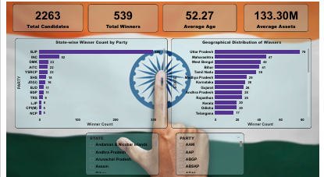

Dashboard 2:
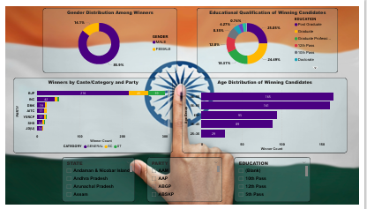

Dashboard 3:
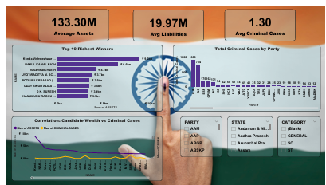

Dashboard 4:

